Mr. Whitby Room 202

5th Grade Virginia Studies

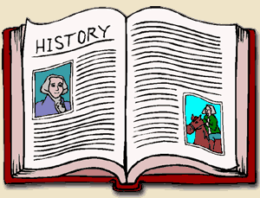

Standards of Learning/Objectives

This year in Virginia Studies we will be discussing the following topics:

•The physical geography of Virginia and the American Indians that lived here

•The colonization of Virginia and its role in the American Revolution

•The role of Virginia in the establishment of a new nation

•The issues that divided the nation and led to the Civil War

•Reconstruction in Virginia following the Civil War

•Virginia from 1900 to the Present

Supplies Rewards

•3-Ring Binder In our class, we will be using an online

•Tab Dividers program known as Class Dojo where the

•Pen (Black/Blue) or Pencils students can earn points daily to redeem for

•Notebook Paper rewards or prizes at a later time.

•Glue Sticks

•Index Cards Resources

•Highlighter Monday – Art

•Colored Pencils, Crayons, or Markers Tuesday – PE

Wednesday – Library

Daily Schedule Friday – Music

Rotation 1 8:05-9:30

Rotation 2 9:30-10:00 Contact Info

Resource 10:00-10:40 Email: douglasw@southampton.k12.va.us

Rotation 2 (cont.) 10:40-11:35 Phone: (757) 562-3007

Lunch 11:35-12:05

Rotation 3 12:05-1:30

Rotation 4 1:30-2:45

Recess 2:45-3:00

